
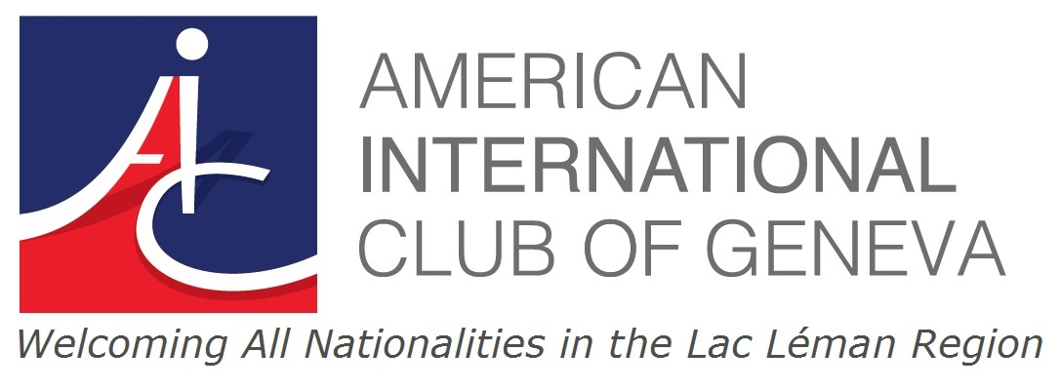

AIC Tennis Tournament
Mixed Doubles Round Robin
Tennis Club de Genève

Friday June 14th
from 5:00pm to 10:00pm

First/ Last Name

email and mobile #

- I confirm my participation for Friday (with dinner)

- I confirm my participation for Friday (without dinner)

Additional info (please check): A B C
- I consider myself an A, B or C player

- A Player = player with ranking who regularly plays competitive tennis
- B Player = player who now plays occasionally but once ( maybe long time ago) played competitively
- C Player = player who just plays for fun and never played competitively

Please email back form to Elena Morier elena.morier@bluewin.ch
Tournament format forces us to limit the number of players
So register soon using this form as space is limited (deadline: Monday June 10th)

