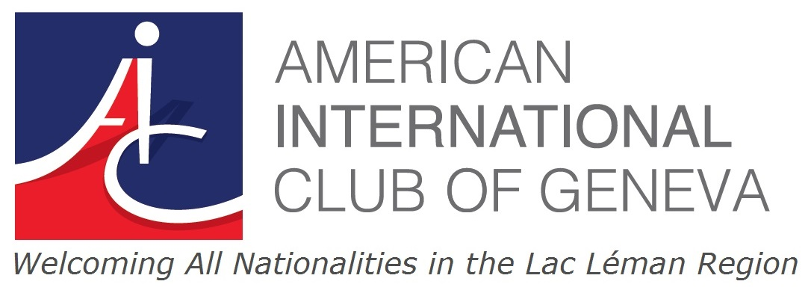

AIC Tennis Tournament
Mixed Doubles Round Robin
Tennis Club de Genève

Saturday July 1st
from 8:30am through 3:00pm

First/ Last Name

email and mobile #

- I confirm my participation for Saturday (with lunch)

- I confirm my participation for Saturday (without lunch)

Additional info (please check): A B C
- I consider myself an A, B or C player

- A Player = player with ranking who regularly plays competitive tennis
- B Player = player who now plays occasionally but once ( maybe long time ago) played competitively
- C Player = player who just plays for fun and never played competitively

Please email back form to Mark Mason mark.s.mason@gmail.com
Tournament format forces us to limit number of players
So register soon using the above form (by Monday June 26th latest)

